Principals Meassage…

Dear Students and Families,

Subject: School Closure – December 12, 2025
Dear Parents and Guardians,

Due to significant flooding in our region, all schools and childcare facilities in the Abbotsford School District will be closed today, Friday, December 12, 2025.
Some schools have been directly impacted by flooding, and many families and staff are unable to travel safely. In addition, many teachers and district staff cannot get to work, resulting in a shortage that makes it impossible to operate schools today.
Please be assured that the district is doing everything possible to reopen schools on Monday, December 15, 2025. We will continue to monitor the situation closely and keep you informed of any changes.
Regarding the Christmas Concert and other scheduled events, Ms. Lincoln and Ms. Michelle will communicate any updates by email should adjustments be necessary.
Thank you for your understanding and cooperation as we prioritize the safety of our students, staff, and families.

Stay safe,
Ms. Lincoln
Principal

Weekly Calendar- December 15-19 2025
15 | Food Bank Items Due (morning)  Christmas Concert 6:30 pm, Bring a food donation one item per person when you arrive at the Church, Don’t forget to donate your bake sale items that you signed up for, Doors open at 5:30 for the bake sale  Red and Green Day – wear red and green
16 | Santa Hat Day – wear your Christmas-y head gear or reindeer antlers  Holiday Magician Assembly! 1:30
17 | Winter Wonderland Day – white and blue theme; earmuffs, toques and scarves  Report Cards Go Home
18 | Ugly Christmas Sweater Day  Decorate Gingerbread Houses  Pizza Party for the class that brought in the most donations
19 | Pajama Day  Christmas Carol singing with Mr. McAuley AM  Christmas Movie in afternoon  December Birthdays  Last Day of School Before Christmas Break! 1st Day Back is Jan 5

District Message sent to all Families through email.
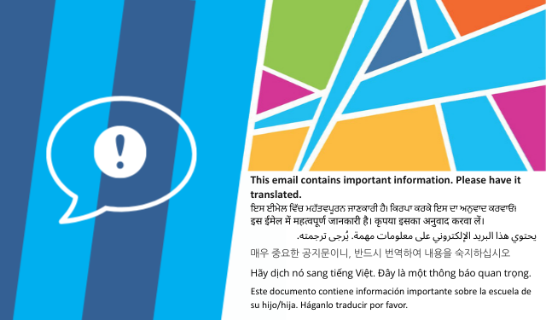
Schools Closed December 12, 2025
Good evening,
Please note all Abbotsford School District schools and district sites (including childcare centres) will be closed to staff and students on Friday, December 12, 2025, due to flood-related operational impacts.
Thank you and stay safe.

FOOD BANK DONATIONS: If you wish to donate, please submit your non-perishable household items by the morning of December 15th. The class who collects the most will win a pizza lunch!

CHRISTMAS CONCERT: Monday, December 15th at 6:30pm at Ross Rd. Community Church (3160 Ross Rd.)
5:30 pm Doors open for the bake sale. *IMPORTANT*: Please supervise your children closely from 5:30 to 6:15 and do not allow them to run/play in the church.
6:15 pm (Not Before) Students meet with their teacher in the church gym to get set up
6:30 Production will begin

WINTER CLOTHING: A reminder to please send students to school with heavy coats, raincoats, boots and gloves when necessary. Also, please replenish changes of clothing at school in case of accidents.

SPIRIT WEAR: If you would like to purchase Mt. Lehman merch, please go to SchoolCashOnline SchoolCashOnline | Abbotsford School District (Nov 28 was the deadline for orders to be here in time for Christmas)

SPIRIT WEEK: December 15-19! The best way to spread Christmas cheer is to dress up loud for all to hear! Each day has a theme. Please see below for each day’s theme.

CALENDAR

December:
15 | Food Bank Items Due (morning)  Christmas Concert 6:30 pm  Red and Green Day – wear red and green
16 | Santa Hat Day – wear your Christmas-y head gear or reindeer antlers  Holiday Magician Assembly! 1:30
17 | Winter Wonderland Day – white and blue theme; earmuffs, toques and scarves  Report Cards Go Home
18 | Ugly Christmas Sweater Day  Decorate Gingerbread Houses
19 | Pajama Day  Christmas Carol singing with Mr. McAuley AM  Christmas Movie in afternoon  December Birthdays  Last Day of School Before Christmas Break! 1st Day Back is Jan 5
January
5 School Reopens
19 Kindergarten Registration Opens
29-30 Lego Workshop

IMPORTANT LINKS AND CONTACTS
Safe Arrival | SafeArrival | Abbotsford School District
School Calendar | Calendar | Mt. Lehman Elementary
SchoolCashOnline | SchoolCashOnline | Abbotsford School District
Contact Your Child’s Teacher | School Staff | Mt. Lehman Elementary
Before/After School Care | Eco Kids Care ecokids2013@gmail.com
Preschool | Eco Kids Care ecokids2013@gmail.com

